**Marriage Trends in India: A Data-Driven SQL Analysis**

**©Prasanjit Rout ||** [**LinkedIn**](https://www.linkedin.com/in/routprasanjit933/)

**Summary**

This project analyzes 10,000 marriage records in India using SQL queries to uncover patterns in age, caste, religion, parental approval, dowry, divorce, and marital satisfaction. The goal is to derive meaningful insights into societal trends and correlations between these factors.

**Dataset Source**

Kaggle

**Key Columns from Dataset**

* Marriage_Type: Love or Arranged marriage
* Parental_Approval: Whether parents approve the marriage
* Divorce_Status: If the marriage ended in divorce
* Income_Level: Income category of individuals
* Dowry_Exchanged: Whether dowry was given
* Marital_Satisfaction: Satisfaction level of the marriage

**Insights & Findings**

After running the queries, I have found some interesting key insights:

* Divorce rates are higher in inter-caste marriages than same-caste marriages.
* Individuals from higher income levels are less likely to exchange dowry.
* Marital satisfaction is generally higher for arranged marriages than love marriages after 10+ years.
* People with higher education tend to marry later in life.
* Parental approval correlates negatively with divorce rates.

**Creating Table and Importing Dataset to Server**

CREATE DATABASE MarriageAnalysis;

USE MarriageAnalysis;

CREATE TABLE MarriageData (

ID INT PRIMARY KEY,

Marriage_Type TEXT,

Age_at_Marriage INT,

Gender TEXT,

Education_Level TEXT,

Caste_Match TEXT,

Religion TEXT,

Parental_Approval TEXT,

Urban_Rural TEXT,

Dowry_Exchanged TEXT,

Marital_Satisfaction TEXT,

Divorce_Status TEXT,

Children_Count INT,

Income_Level TEXT,

Years_Since_Marriage INT,

Spouse_Working TEXT,

Inter_Caste TEXT,

Inter_Religion TEXT

);

SHOW VARIABLES LIKE 'secure_file_priv';

**Data Importing**

LOAD DATA INFILE 'C:/ProgramData/MySQL/MySQL Server 8.0/Uploads/marriage_data_india.csv'

INTO TABLE MarriageData

FIELDS TERMINATED BY ','

ENCLOSED BY '"'

LINES TERMINATED BY '\n'

IGNORE 1 ROWS;

**Problem Statements & SQL Queries**

**(All the queries have successfully Executed )**

**Basic Queries**

1. **Retrieve all records where Marriage_Type is "Love".**



1. **Count the number of marriages where Parental_Approval is "Yes".**

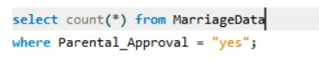

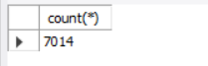

1. **Find the average Age_at_Marriage for males and females separately.**

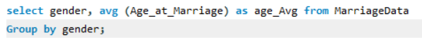

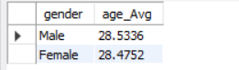

1. **Get the number of people with a Graduate education level.**

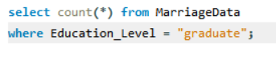



1. **Find the count of marriages where Dowry_Exchanged is "Yes".**

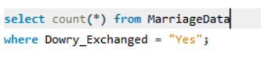 

1. **List the top 5 most common Education_Level values and their frequencies.**

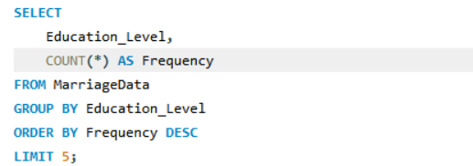

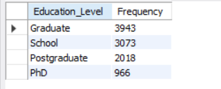

1. **Calculate the percentage of inter-caste marriages (Inter-Caste = "Yes") in the dataset.**

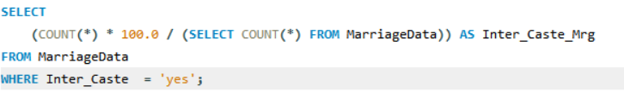

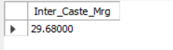

1. **Find the highest, lowest, and average Years_Since_Marriage.**

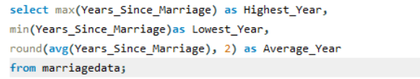



1. **Identify the most common income level among those who got divorced.**

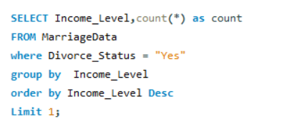

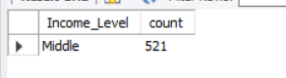

1. **Count the number of urban and rural marriages separately.**

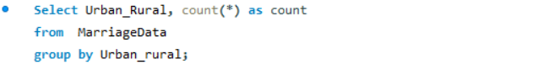

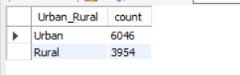

1. **Find the correlation between Parental_Approval and Divorce_Status (how many divorces occur in approved vs. non-approved marriages).**

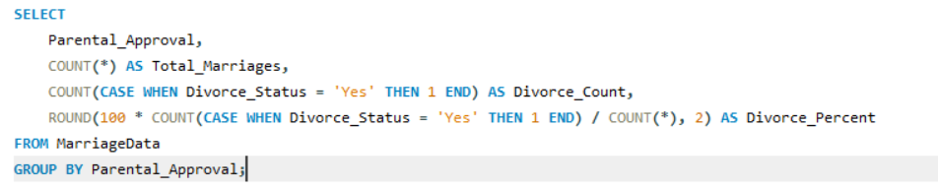

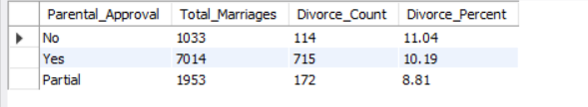

1. **Determine the percentage of marriages where Spouse_Working is "Yes" and Marital_Satisfaction is "High".**

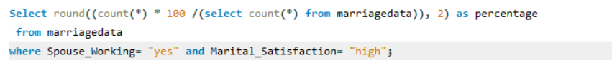

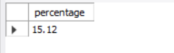

1. **Find the average number of children_Count for arranged vs. love marriages.**



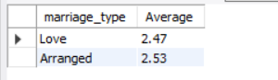

1. **Count how many inter-religion marriages also have Inter-Caste = "Yes".**

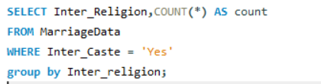

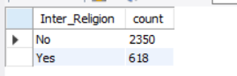

1. **Find the percentage of individuals with a Postgraduate degree who had an arranged marriage.**

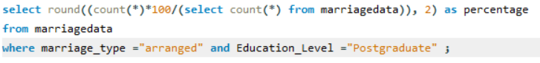

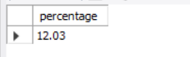

1. **Analyze whether Years_Since_Marriage correlates with Marital_Satisfaction.**
2. **Calculate the average Children_Count for different Marital_Satisfaction levels.**

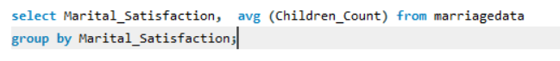

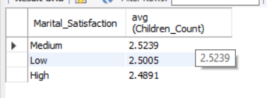

1. **Find the proportion of people with middle income who have experienced divorce.**

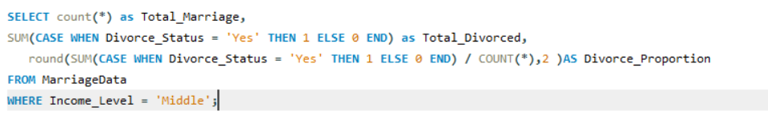

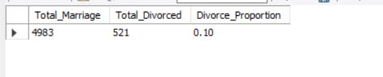

1. **Identify the most common combination of education and marriage_type among urban vs. rural populations.**

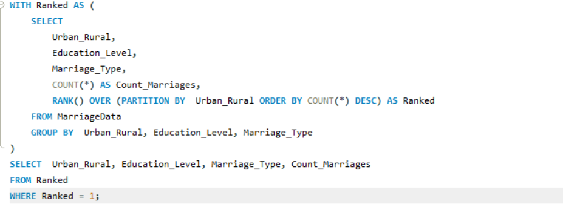

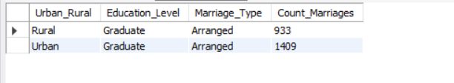

1. **Determine the average age_at_Marriage for divorced vs. non-divorced individuals.**

